Database Management System – cs422 DE
Lab 1 – Wk 3 & 4
-----------------------------------------------------------------------------------------------------------------
This Lab is based on lecture 3 & 4 (chapters 6 & 7).
- Submit your own work on time. No credit will be given if the lab is submitted after the due date.
- Note that the completed lab should be submitted in .zip or .rar format only.
- If you think that your answer needs explanation to get credit then please write it down.
---------------------------------------------------------------------------------------------------------------

Solve the questions from 6.32 to 6.40 in the Case Study 2 on page no. 173 (5th edition).

You are required to run & test all these queries in SQL Server. Note that you’ll need to create and populate the tables first.

To get full credit for this lab, you need to submit the following:
- Screenshots for at least 4 of the queries with output.
- Answer SQL queries for all of the mentioned exercises.

For your quick reference, the schema and the questions are given below.
Employee (empID, fName, lName, address, DOB, sex, position, deptNo)
Department (deptNo, deptName, mgrEmpID)
Project (projNo, projName, deptNo)
WorksOn (empID, projNo, hoursWorked)
where
- Employee contains employee details and empID is the key.
- Department contains department details and deptNo is the key. mgrEmpID identifies the employee who is the manager of the department. There is only one manager for each department.
- Project contains details of the projects in each department and the key is projNo (no two departments can run the same project).
- WorksOn contains details of the hours worked by employees on each project, and empID/projNo form the key.

Exercises

- List all employees in alphabetical order of surname and within surname, first name.
ANS:
SELECT *
FROM Employee
ORDER BY lName ASC, fName ASC;

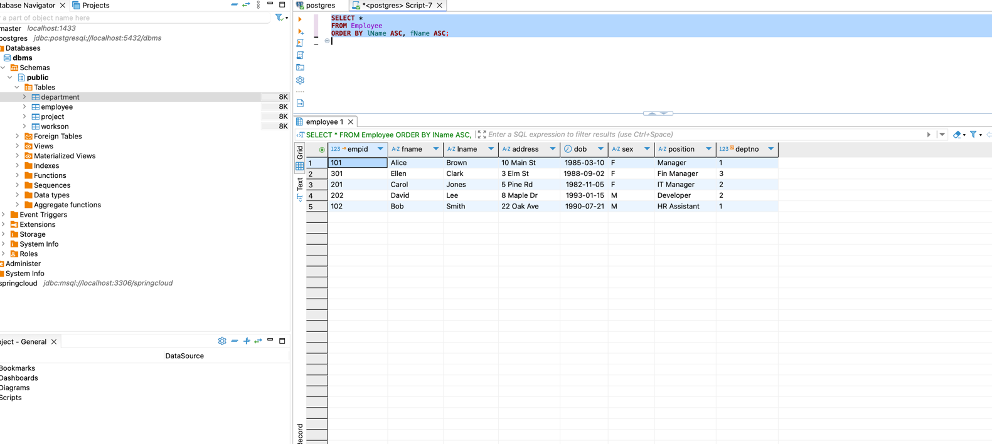

- List all the details of employees who are female.
ANS:
SELECT *
FROM Employee
WHERE sex = 'F';

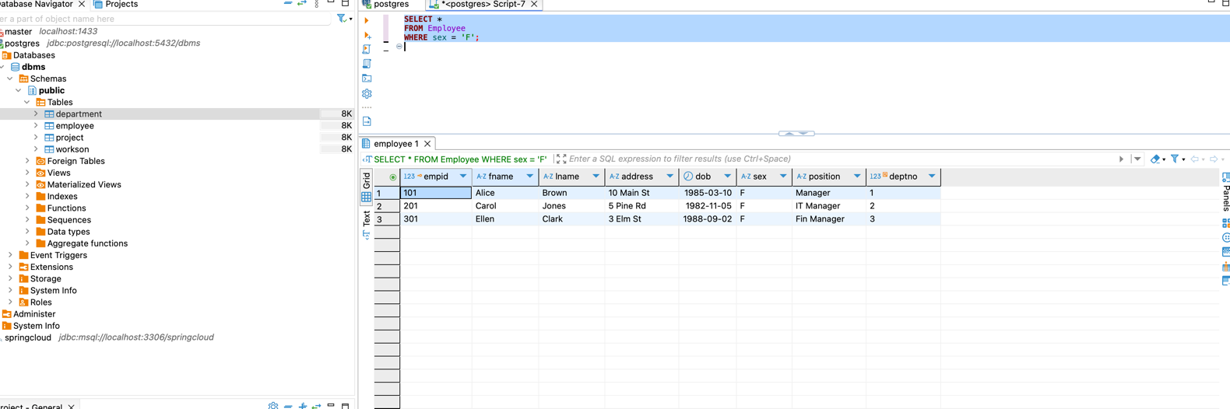

- List the names and addresses of all employees who are Managers.
ANS:
SELECT E.fName, E.lName, E.address
FROM Employee E
JOIN Department D ON E.empID = D.mgrEmpID;

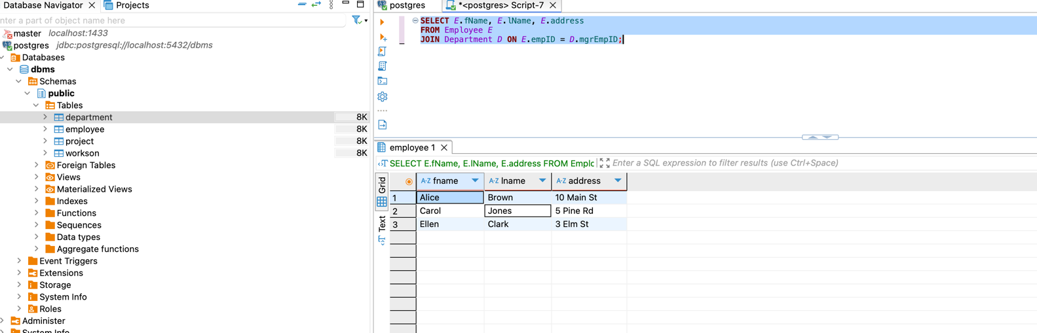
- Produce a list of the names and addresses of all employees who work for the IT department.
ANS:
SELECT E.fName, E.lName, E.address
FROM Employee E
JOIN Department D ON E.deptNo = D.deptNo
WHERE D.deptName = 'IT';
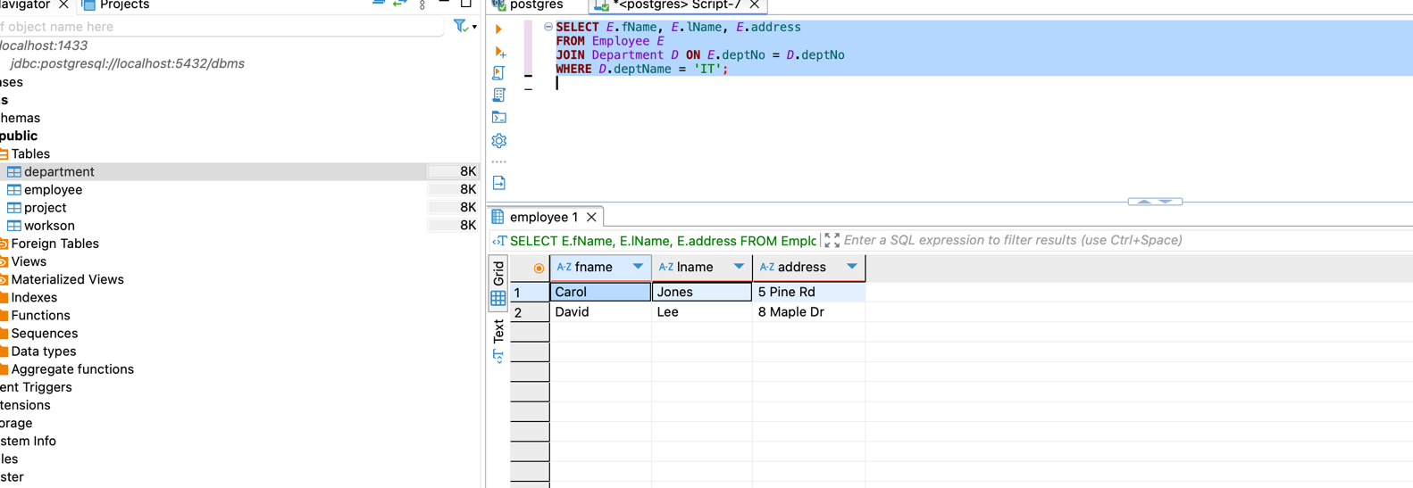

- Produce a complete list of all managers who are due to retire this year, in alphabetical order of surname.
ANS:
SELECT E.*
FROM Employee E
JOIN Department D ON E.empID = D.mgrEmpID
WHERE (EXTRACT(YEAR FROM CURRENT_DATE) - EXTRACT(YEAR FROM E.DOB)) >= 65
ORDER BY E.lName ASC;

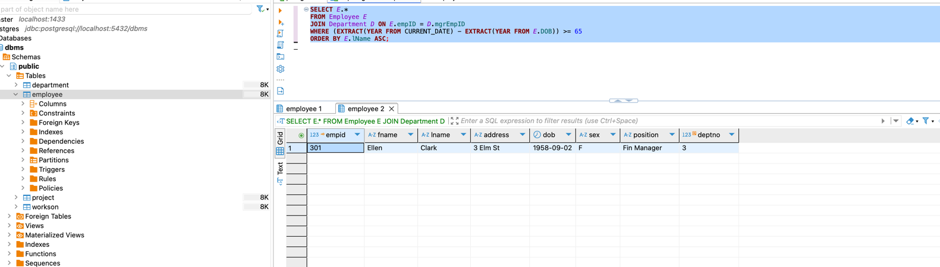
- Find out how many employees are managed by ‘James Adams’.
ANS:
SELECT COUNT(*)
FROM Employee
WHERE deptNo = (
SELECT D.deptNo
FROM Department D
JOIN Employee E ON D.mgrEmpID = E.empID
WHERE E.fName = 'James' AND E.lName = 'Adams'
);

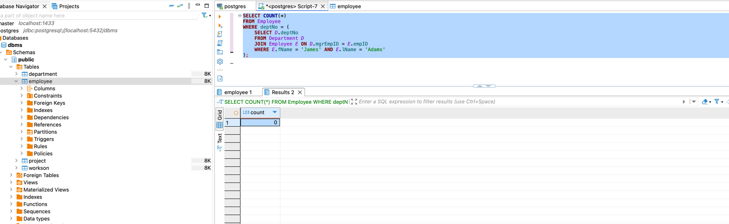

- Produce a report of the total hours worked by each employee, arranged in order of department number and within department, alphabetically by employee surname.
ANS:
SELECT
E.deptNo,
E.fName,
E.lName,
SUM(W.hoursWorked) AS TotalHoursWorked
FROM Employee E
LEFT JOIN WorksOn W ON E.empID = W.empID
GROUP BY E.empID, E.deptNo, E.fName, E.lName
ORDER BY E.deptNo ASC, E.lName ASC;

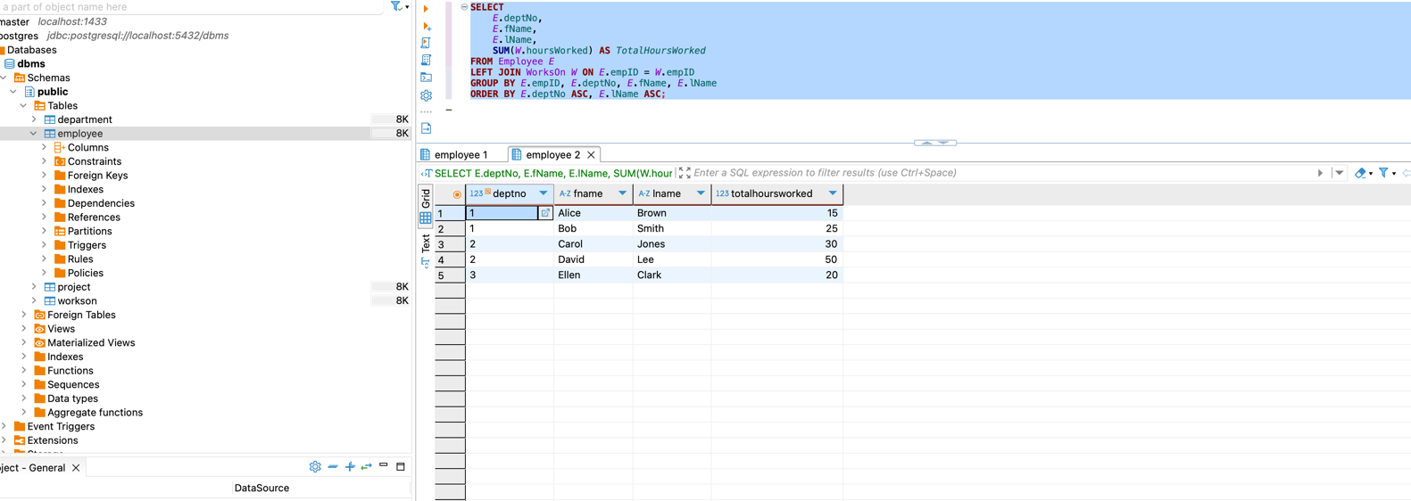
- For each project on which more than two employees worked, list the project number, project name and the number of employees who work on that project.
ANS:
SELECT
P.projNo,
P.projName,
COUNT(W.empID) AS NumberOfEmployees
FROM Project P
JOIN WorksOn W ON P.projNo = W.projNo
GROUP BY P.projNo, P.projName
HAVING COUNT(W.empID) > 2;

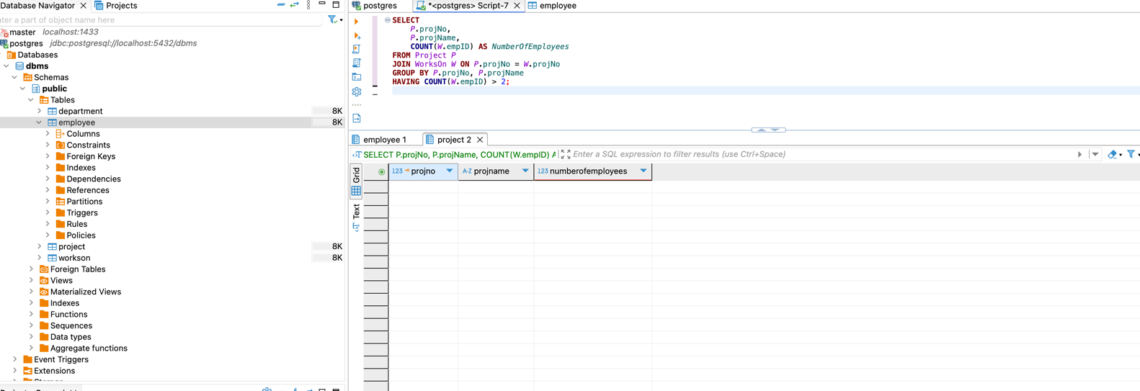
- List the total number of employees in each department for those departments with more than 10 employees. Create an appropriate heading for the columns of the results table.
ANS:
SELECT
D.deptName AS "Department Name",
COUNT(E.empID) AS "Total Employees"
FROM Department D
JOIN Employee E ON D.deptNo = E.deptNo
GROUP BY D.deptName
HAVING COUNT(E.empID) > 10;

